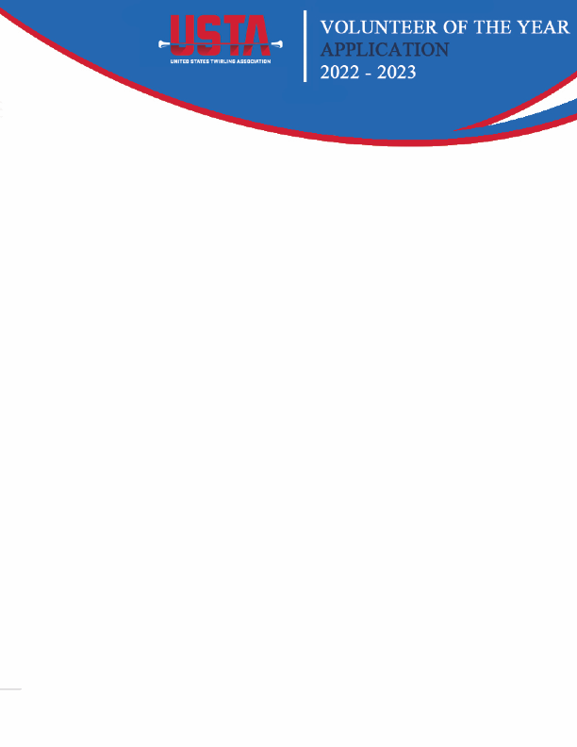

**DEADLINE:**

**MAY 31, 2023**

**HONORED: At the U.S. National Baton Twirling Championships in Kissimmee, FL.**

**REWARD: $250 cash award and an exclusive interview for publication in USTA’s News & Views.**

First and Last Name of Nominee:

Member Status (circle):

Active Non-member Alumni

Provide key qualities, traits, and characteristics of the nominee

Reason for nomination

Describe how the nominee demonstrates excellence in the area of teamwork (give specific examples)

Describe how the nominee contributes and supports the sport of baton twirling through volunteerism